**P235/2**

**Islamic Religious Education**

**(Hadith and Fiqh)**

**Paper 2**

**July/August 2019**

**2 ½ HOURS**

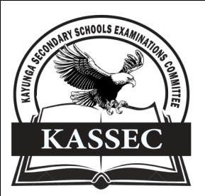

**KAYUNGA SECONDARY SCHOOLS EXAMINATION COMMITTEE**

***Uganda Advanced Certificate of Education***

**JOINT MOCT EXAMS 2019**

**ISLAMIC RELIGIOUS EDUCATION**

**(HADITH AND FIQH)**

**PAPER TWO**

**2 HOURS 30 MINUTES**

**INSTRUCTIONS TO CANDIDATES**

* This paper is divided into **two** sections **A** and **B**
* Answer any four questions, taking **at least one** from each section.
* All questions carry equal marks
* Any additional question(s) answered will not be marked.

**SECTION A**

**HADITH (TRADITONS OF THE PROPHET)**

1. Examine the role of Imam Malik bin Anas to the development of Hadith literature. *(25 marks)*

2. Discuss the contribution of Al –Bukhar to the compilation of Hadith. *(25 marks)*

3. In judging al – Misal’s works, he was included among the sound compilers. Analyse the criteria he used in compiling authentic traditions. *(25 marks)*

4. The practice of forging Hadith was detrimental but at the same time meritorious to Muslim practice. Discuss *(25 marks)*

5. (a) Account for the inclusion of Dhaif among the classes of Hadith *(13 marks)*

(b) Explain the impact of classification of the study of Hadith. *(12 marks)*

6. Analyse the characteristics of Hadith al – Qudsi. *(25 marks)*

**SECTION B**

**FIQH (PRACTICE)**

7. Account for the development of Islamic law up to 850AD. *(25 mark)*

8. Compare the Qur’an and Hadith as sources of Islamic law. *(25 marks)*

9. Discuss the origin of the legal classification of acts in Islam. *(25 marks)*

10. Discuss the biography and contribution of Imam Hanbal to the study of Islamic jurisprudence. *(25 marks)*

11. Explain the teachings of Islam on dignity of a woman. *(25 marks)*

12. (a) Discuss the struggle to apply sharia in Algeria *(13 marks)*

(b) Explain the challenges they faced in the struggle to apply sharia. *(12 marks)*

**END**